Database Name - Insurance DB
To create :-
- Create database Insurance DB
CREATE TABLE Policies (
policy_id INT PRIMARY KEY,
PolicyName VARCHAR(50),
PolicyType VARCHAR(50),
PreAmount INT,
durationyears INT
);

CREATE TABLE Agents (
agentid INT PRIMARY KEY,
agentname VARCHAR(50),
phone VARCHAR(15),
city VARCHAR(50)
);

CREATE TABLE Customer (
Customer_id INT PRIMARY KEY,
FirstName VARCHAR(50),
LastName VARCHAR(50),
Phone VARCHAR(15),
Dateofbirth DATE,
Email VARCHAR(100)
);

INSERT INTO Policies VALUES
(201, 'Life Secure Plan', 'Life Insurance', 50000, 20);

CREATE TABLE PolicyAssignment (
AssId INT PRIMARY KEY,
Customer_id INT,
policy_id INT,
agentid INT,
startdate DATE,
enddate DATE,
CONSTRAINT FK_Assign_customer FOREIGN KEY (Customer_id)
REFERENCES Customer(Customer_id),
CONSTRAINT FK_Assign_policy FOREIGN KEY (policy_id)
REFERENCES Policies(policy_id),
CONSTRAINT FK_Assign_agent FOREIGN KEY (agentid)
REFERENCES Agents(agentid)
);

INSERT INTO PolicyAssignment VALUES
(1, 101, 201, 301, '2024-01-01', '2025-01-01');

CREATE TABLE Claims (
claimid INT PRIMARY KEY,
assignmentid INT,
claimDate DATE,
claimamount INT,
claimstatus VARCHAR(20),
CONSTRAINT FK_Claims_Assignment FOREIGN KEY (assignmentid)
REFERENCES PolicyAssignment(AssId)
);

INSERT INTO Claims
(claimid, assignmentid, claimDate, claimamount, claimstatus)
VALUES
(101, 1, '2024-06-15', 50000, 'Approved');

INSERT INTO Customer
(Customer_id, FirstName, LastName, Phone, Dateofbirth, Email)
VALUES
(101, 'Srinidhi', 'Kommawar', '9063440835', '2004-09-10', 'srinidhikommawar109@gmail.com');

To create tables:
- Select – what you want to see
- From – source i.e table
- Where – to retrieve specific tables using condition
- Order by – Column sort asc/desc
- Group by – Aggregation function - on group of records
- Having condition – to filter the rows after group by – Having will ba always associated with group by
- Synonym – Alias Name to an entity
- No alter command is present for synonym
- Offset – skip rows
- Fetch – skip 10 show 5 – it fetches 5 records
- Limiting the rows – top(10) , limit
- Where clause operators – = , <>,<,>,<=,>=,!<, !>, between , null
- Between operator usage
Select * from emp where salary between 20000 and 50000 – for specific range we need to use between operator
- IN operator usage
Select * from emp where city in(‘hyd’,’delhi’);
- Like operator usage
Select ename from employee where ename like ‘A%’;
- ___ - empname whose size = 3
- [EJ]% First char can be E/J
- [^EJ]% First char not be E/J
Practice
Select commands:
- select * from Customer where FirstName like 'S%';

- select Email from Customer where email like '%@gmail.com';

- select agentname from Agents where city = 'Hyderabad';

- select Customer_id , policy_id from PolicyAssignment;

- select * from PolicyAssignment where agentid = 302;

- select claimId from Claims where claimstatus = 'Approved';

- select sum(claimamount) as total from Claims where claimstatus = 'Pending';

- select claimstatus , sum(claimamount) as total from Claims group by claimstatus;

- select c.FirstName , c.LastName , p.PolicyName from Customer c
join PolicyAssignment pa on pa.Customer_id = c.Customer_id
join Policies p on pa.policy_id = p.policy_id;

Text Functions –

- select FirstName + '('+Phone +')' + '('+Email +')' as Name from Customer order by FirstName;
- select FirstName + LastName from Customer;
- select FirstName from Customer where FirstName like 'A%';
- select LastName from Customer where len(LastName) >6;
- select Left(FirstName,3) as Name from Customer;
- Select Replace(PolicyName ,'secure','security') from Policies;
- select city from agents where city like 'hyd%';
- select PolicyName ,len(PolicyName) as length from Policies;
- select Right(PolicyType,3)from Policies;
- select Trim(FirstName)from Customer;

Numeric Functions –

- select lower(FirstName) from Customer;
- select round(preAmount,2) from Policies;
- select PolicyName , round(preAmount,2) as amount from Policies where round(preAmount,2) > 5000;
- select abs(claimamount) from Claims;
- select (preAmount/100)*10 as tax from Policies;
- select SQUARE(preAmount) from Policies;
- select CEILING(claimamount) from Claims;
- select Floor(claimamount) from Claims;
- select preAmount + (preAmount/100)*18 as total from Policies;
- select * from PolicyAssignment;
Date Functions –
- select GETDATE();
- select p.PolicyName as names from Policies p join PolicyAssignment pa on p.policy_id = pa.policy_id where pa.startdate like '2025%';
- select DATEDIFF(day , startdate , enddate) as duration from PolicyAssignment
- select DATENAME(Month ,startdate) as month from PolicyAssignment;
- select policy_id from PolicyAssignment where datename(weekday,startdate) = 'Monday';
Aggregate Functions -
- select count(Customer_id) from Customer;
- select sum(preAmount)from Policies;
- select AVG(preAmount) from Policies;
- select max(claimamount) from Claims;
- select min(claimamount) from Claims;
- select count(*) as policies_count , PolicyType from policies group by PolicyType;
- select sum(claimamount) as total_claim , claimstatus from Claims group by claimstatus;
- select PolicyType from Policies where avg(preAmount) > 5000;

JOINS – arbitrary condition / join keywords

--Cartesian Product
select * from Customer,PolicyAssignment;
--Inner join
select * from Customer c
join PolicyAssignment pa on pa.Customer_id = c.Customer_id;
--Right join
select * from Customer c
right join PolicyAssignment pa on pa.Customer_id = c.Customer_id;
--Left join
select * from Customer c
left join PolicyAssignment pa on pa.Customer_id = c.Customer_id;
--Full Join
select * from Customer c
full outer join PolicyAssignment pa on pa.Customer_id = c.Customer_id;
--1. List all Policies for a CustomerId 5(inplace of 5 took 101 based on my insert queries).
select c.FirstName , c.LastName , p.PolicyName from Customer c
join PolicyAssignment pa on pa.Customer_id = c.Customer_id
join Policies p on pa.policy_id = p.policy_id where c.Customer_id = 105;
--2. View all customers with their policies.
select c.FirstName , c.LastName , p.PolicyName from Customer c
join PolicyAssignment pa on pa.Customer_id = c.Customer_id
join Policies p on pa.policy_id = p.policy_id ;
--3. View claims with customer name it also accepts null.
select cu.FirstName,cu.LastName , C.claimid,C.claimDate,C.claimamount,C.claimstatus from Customer cu
left join PolicyAssignment pa on pa.Customer_id = cu.Customer_id
left join Claims C on pa.AssId = C.assignmentid;
--4. Display FirstName, PolicyName, AgentName, StartDate and EndDate from their respective tables.
select c.FirstName,c.LastName,p.PolicyName,a.agentname,pa.startdate,pa.enddate
from Customer c join PolicyAssignment pa on pa.Customer_id = c.Customer_id
join Policies p on pa.policy_id = p.policy_id
join Agents a on pa.agentid = a.agentid;
--5.Display claims report with FirstName, PolicyName, ClaimAmount, ClaimStatus, and ClaimDate from their respective tables.
select c.FirstName , p.PolicyName , cl.claimAmount , cl.claimstatus , cl.claimDate
from Customer c join policyAssignment pa on pa.Customer_id = c.Customer_id
join Policies p on pa.policy_id = p.policy_id
join Claims cl on pa.AssId = cl.assignmentid;
Set Operations
--21. Customers who bought Life OR Health policies.
select c.Customer_id , c.FirstName , c.LastName
from Customer c
join PolicyAssignment pa on pa.Customer_id = c.Customer_id
join Policies p on p.policy_id = pa.policy_id
where p.PolicyType = 'Life Insurance'
UNION
select c.Customer_id , c.FirstName , c.LastName
from Customer c
join PolicyAssignment pa on pa.Customer_id = c.Customer_id
join Policies p on p.policy_id = pa.policy_id
where p.PolicyType = 'Financial Insurance';

--22.Customers who bought both Life AND Health.
select c.Customer_id , c.FirstName , c.LastName
from Customer c
join PolicyAssignment pa on pa.Customer_id = c.Customer_id
join Policies p on p.policy_id = pa.policy_id
where p.PolicyType = 'Life Insurance'
Intersect
select c.Customer_id , c.FirstName , c.LastName
from Customer c
join PolicyAssignment pa on pa.Customer_id = c.Customer_id
join Policies p on p.policy_id = pa.policy_id
where p.PolicyType = 'Financial Insurance';

--23.Customers who bought Life but NOT Health.
select c.Customer_id , c.FirstName , c.LastName
from Customer c
join PolicyAssignment pa on pa.Customer_id = c.Customer_id
join Policies p on p.policy_id = pa.policy_id
where p.PolicyType = 'Life Insurance'
Except
select c.Customer_id , c.FirstName , c.LastName
from Customer c
join PolicyAssignment pa on pa.Customer_id = c.Customer_id
join Policies p on p.policy_id = pa.policy_id
where p.PolicyType = 'Financial Insurance';

--24.All customers with policies (allow duplicates).
select c.Customer_id , c.FirstName , c.LastName
from Customer c
join PolicyAssignment pa on pa.Customer_id = c.Customer_id
join Policies p on p.policy_id = pa.policy_id
where p.PolicyType = 'Life Insurance'
union all
select c.Customer_id , c.FirstName , c.LastName
from Customer c
join PolicyAssignment pa on pa.Customer_id = c.Customer_id
join Policies p on p.policy_id = pa.policy_id
where p.PolicyType = 'Financial Insurance';

--25.Distinct customers with policies.
select Customer_id,FirstName,LastName from Customer
Intersect
select c.Customer_id,c.FirstName,c.LastName from Customer c
join PolicyAssignment pa on pa.Customer_id = c.Customer_id;
--26 Policies having claims OR assignments
select policy_id from PolicyAssignment
union
select pa.policy_id from Claims c
JOIN PolicyAssignment pa
ON c.assignmentID = pa.AssId;

--27.Policies with claims but no assignments (data issue).
select pa.policy_id from Claims c
JOIN PolicyAssignment pa
ON c.assignmentID = pa.AssId
except
select policy_id from PolicyAssignment

--28.Common policies in Claim and Assignment
select policy_id from PolicyAssignment
intersect
select pa.policy_id from Claims c
JOIN PolicyAssignment pa
ON c.assignmentID = pa.AssId;

--29.Customers with policies but no claims.
select c.Customer_id,c.FirstName,c.LastName
from Customer c
join PolicyAssignment pa on c.Customer_id = pa.Customer_id
except
select c.Customer_id,c.FirstName,c.LastName from Customer c
join PolicyAssignment pa on pa.Customer_id = c.Customer_id
join Claims cl on cl.assignmentid = pa.AssId

--30. Combine all customer IDs from mul􀆟ple sources.
select Customer_id from Customer c
union all
select Customer_id from PolicyAssignment p

Database Diagram

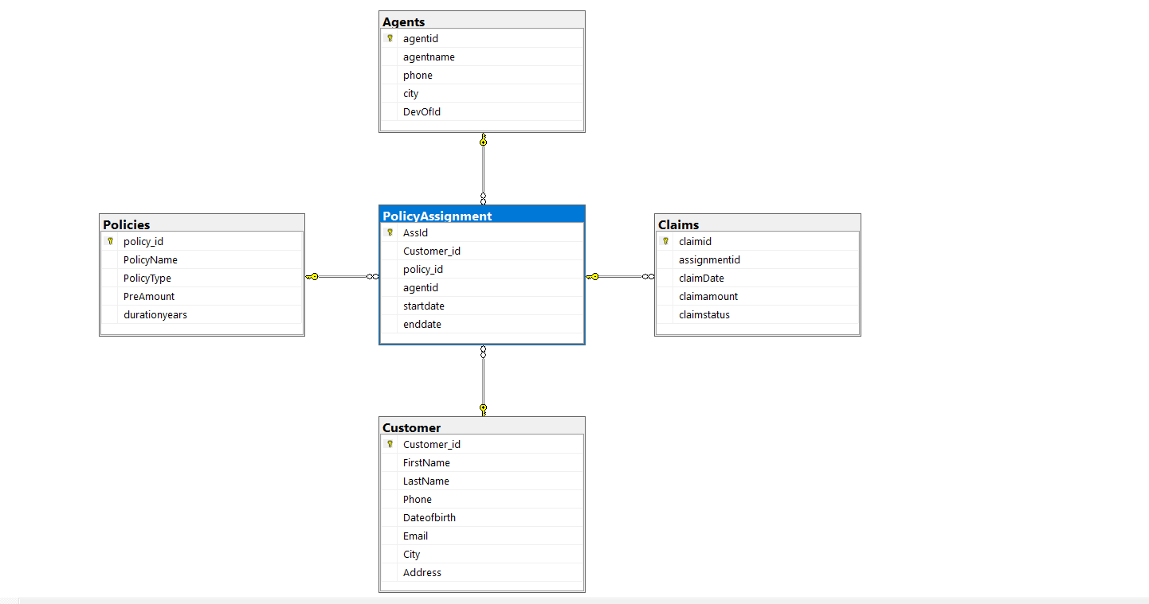

--CASE-ELSE example
Categorize Policy Based on Premium Amount
select PolicyName,PreAmount,
case
when PreAmount >= 80000 THEN 'High Premium'
when PreAmount BETWEEN 30000 AND 79999 THEN 'Medium Premium'
else 'Low Premium'
end as PremiumCategory
from Policies;

Merge Example
MERGE Example on Claims
CREATE TABLE NewPolicies (
policy_id INT,
PolicyName VARCHAR(50),
PolicyType VARCHAR(50),
PreAmount INT,
durationyears INT
);
INSERT INTO NewPolicies VALUES
(201, 'Life Secure Plan', 'Life Insurance', 55000, 20), -- existing (update)
(203, 'Health Plus Plan', 'Health Insurance', 40000, 5); -- new (insert)
Merge code
merge policies as target
using NewPolicies as source
on target.policy_id = source.policy_id
when matched then
update set
target.PolicyName = source.PolicyName,
target.PolicyType = source.PolicyType,
target.PreAmount = source.PreAmount,
target.durationyears = source.durationyears
when not matched by target then
insert (policy_id, PolicyName, PolicyType, PreAmount, durationyears)
values (source.policy_id, source.PolicyName, source.PolicyType, source.PreAmount, source.durationyears);
Roll up
Total Claim Amount by Status + Grand Total
select claimstatus,SUM(claimamount) AS TotalAmount
from Claims
group by rollup(claimstatus);
Cube
Agent-wise & Policy-wise Policy Count
select agentid,policy_id,
COUNT(*) as PolicyCount
from PolicyAssignment
group by cube(agentid, policy_id);
Grouping Sets
SELECT
agentid,
COUNT(*) AS TotalPolicies
FROM PolicyAssignment
GROUP BY GROUPING SETS (
(agentid),
()
);

